**Assignment 2 - 1930026143**

1. We know that $ε=0.2$ and $L_{0}=x_{s}-x_{t}=5-\left(-3\right)=8$.

For Exhaustive Search Method:

$$N>\frac{2*L_{0}}{ε}=\frac{16}{0.2}-1=79$$

Thus, there are 80 function values at least should be calculated in this case.

For Golden Section Method:

$$N≥\log_{τ}\left(\frac{ε}{L_{0}}\right) where τ≈0.618 (golden ratio)$$

After computing, we can get $N≥7.6649$. Since $N$ must be an integer, there are 8 function values at least should be calculated in this case.

1. $f\left(x\right)=x^{2}+2x+1$. We can calculate and determine the case step by step.

Step1: $\overline{x}=x_{s}+τL_{0}=1.944$

$\hat{x}=x_{s}+\left(1-τ\right)L_{0}=0.056$

$f\left(\overline{x}\right)={1.944}^{2}+2*1.944+1=8.6671$

$f\left(\hat{x}\right)={0.056}^{2}+2*0.056+1=1.1151$

Since $f\left(\hat{x}\right)>f\left(\hat{x}\right)$, the interval $\left[x_{s}, x_{t}\right]→[x_{s}, \overline{x}]$, which means that $x_{t}^{1}=\overline{x}$.

According to the question (1), there are have 8 steps in the case that the length of the final interval of uncertainty needs to be less than 0.2. So we can solve this problem by coding:

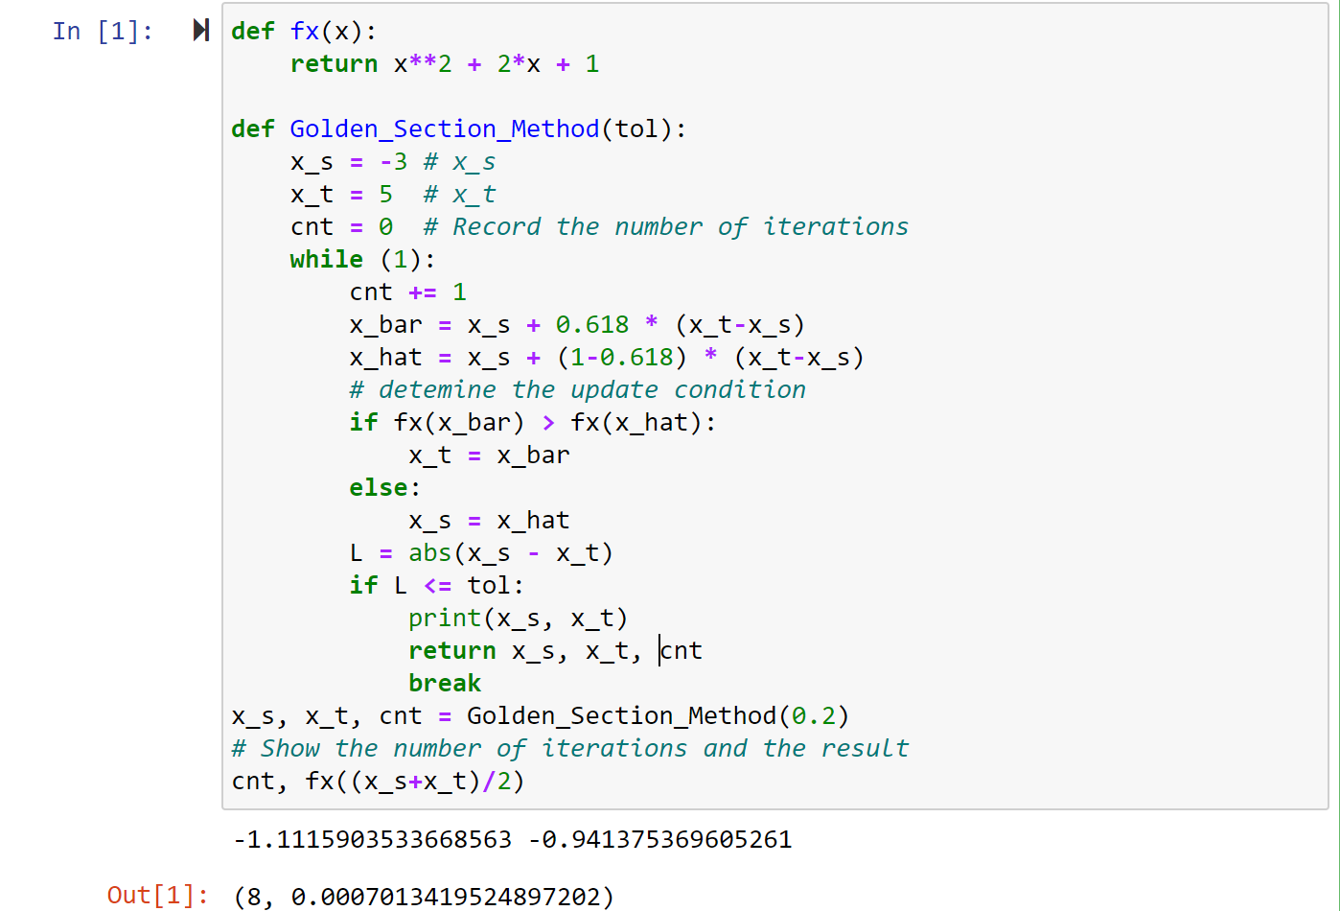

As we can see that the final interval is $(-1.1116, -0.9414)$ and there are 8 function values at least should be calculated. And the minimum point of function is 0.0070134.

1. Let $g\left(x\right)=x^{4}-1$, we should minimize it by using the Newton’s Method, which means that we should transform the “find the minimum problem” to “Zero problem” by the first derivative. $g^{'}\left(x\right)=4x^{3}$ and $g^{''}\left(x\right)=12x^{2}$.

According to Newton’s Method, value update formula as follow:

$$x_{k+1}=x_{k}-\frac{f\left(x_{k}\right)}{f^{'}\left(x_{k}\right)}$$

In this case, $f\left(x\right)=g'(x)$, $x_{0}=4$

Step1: $x_{1}=x_{0}-\frac{4x_{0}^{3}}{12x_{0}^{2}}=4-\frac{156}{192}=2.67$

$g\left(2.67\right)={2.67}^{4}-1≈49.8212$, $f\left(2.67\right)={2.67}^{3}*4≈76.1367$

Step2: $x_{2}=x_{1}-\frac{4x_{1}^{3}}{12x_{1}^{2}}=2.67-\frac{76.1367}{185.5468}=1.78$

$g\left(1.78\right)={1.78}^{4}-1≈9.0388$, $f\left(1.78\right)={1.78}^{3}*4≈22.5590$

Step3: $x_{3}=x_{2}-\frac{4x_{2}^{3}}{12x_{2}^{2}}=1.78-\frac{22.5590}{38.0208}=0.9750$

$g\left(0.975\right)={0.975}^{4}-1≈-0.0963$.

1. Let $g\left(x\right)=x^{4}-1$, we should minimize it by using the Scant Method, which means that we should transform the “find the minimum problem” to “Zero problem” by the first derivative. $g^{'}\left(x\right)=4x^{3}$ and $g^{''}\left(x\right)=12x^{2}$.

According to Newton’s Method, value update formula as follow:

$$x_{k+1}=x_{k}-\frac{x_{k}-x_{k-1}}{f^{'}\left(x_{k}\right)-f\left(x_{k-1}\right)}*f'(x_{k})$$

In this case, $f\left(x\right)=g'(x)$, $x_{0}=4, x_{-1}=6$.

1: $x_{1}=x_{0}-\frac{x_{0}-x_{-1}}{f^{'}\left(x_{0}\right)-f\left(x_{-1}\right)}f^{'}\left(x_{0}\right)=4-\frac{4-6}{256-864}*256≈3.1579$

$f\left(3.1579\right)={3.1579}^{3}*4≈125.9785$

2: $x_{2}=x_{1}-\frac{x_{1}-x_{0}}{f^{'}\left(x_{1}\right)-f\left(x_{0}\right)}f^{'}\left(x_{1}\right)=3.1579-\frac{3.1579-4}{125.9785-256}125.9785≈2.3422$

$f\left(2.3422\right)={2.3422}^{3}*4≈51.3963$

3: $x_{3}=x_{2}-\frac{x_{2}-x_{1}}{f^{'}\left(x_{2}\right)-f\left(x_{1}\right)}f^{'}\left(x_{2}\right)=2.3422-\frac{2.3422-3.1579}{51.3963-125.9785}51.3963≈1.7801$

$g\left(1.7801\right)≈9.0410$

1. We know that the general term $x_{k}=1+5*{10}^{-2k}$, so $x_{k+1}=1+5*{10}^{-2k-2}$.

$$\lim_{k→∞}{x_{k}}= \lim_{k→∞}1+5*{10}^{-2k}=1=(x^{*})$$

Thus, when $p=1$ we have:

$$\lim_{k→∞}\frac{|x_{k+1}-x^{*}|}{{\left|x_{k}-x^{*}\right|}^{p}}=\lim_{k→∞}\left|\frac{5*{10}^{-2k-2}}{5*{10}^{-2k}}\right|=\lim_{k→∞}{{10}^{-2}}=0.02$$

Therefore, the general term is linear convergence and the order of convergence is 1.

(b) We know that the general term $x_{k+1}=\frac{x_{k}}{2}+\frac{2}{x_{k}}$ with the $x_{0}=4$.

In this case, it is difficult to find the limit of $x_{k}$. But we know that as $k$ goes to infinity, $x_{k}$ tends to the smallest. Since we can

${\left(\frac{x_{k}}{2}+\frac{2}{x_{k}}\right)}^{2}=(\frac{4}{{x_{k}}^{2}}+x_{k}^{2})+2$

which has the minimum point when $x_{k}=2$. Thus $x^{*}=2$ and let $p=2$, we have

$\lim_{k→∞}{\frac{\left|x_{k+1}-x^{*}\right|}{{\left|x_{k}-x^{*}\right|}^{p}}}=$ $\lim_{k→∞}{\frac{\left|\frac{x_{k}}{2}+\frac{2}{x_{k}}-2\right|}{{\left|x_{k}-2\right|}^{2}}}=\lim_{k→∞}\left|\frac{\frac{x_{k}^{2}+4-4x_{k}}{2x_{k}}}{{\left(x_{k}-2\right)}^{2}}\right|=\lim_{k→∞}\left(\frac{1}{2x_{k}}\right)=\frac{1}{4}$

Therefore, the convergence is quadratic and the order of convergence is 2.

1. We know that the sequence $y_{k}=cx_{k}$ where $x_{k}$ converges to $x^{*}$ with order $p$ and $c≠0$. For sequence $x_{k}$, it satisfies:

$$\lim_{k→∞}{\frac{\left|x_{k+1}-x^{*}\right|}{{\left|x_{k}-x^{*}\right|}^{p}}}=β$$

Thus, we have:

$$\lim_{k→∞}{y_{k}}=\lim_{k→∞}cx_{k}=c\lim_{k→∞}x_{k}=cx^{*}=y^{*}$$

$$\lim_{k→∞}\frac{\left|y_{k+1}-y^{*}\right|}{{\left|y_{k}-y^{*}\right|}^{p}}=\lim_{k→∞}\left|\frac{cx_{k+1}-{cx}^{*}}{{\left(cx_{k}-cx^{*}\right)}^{p}}\right|=c\lim_{k→∞}{\frac{\left|x_{k+1}-x^{*}\right|}{{\left|x_{k}-x^{*}\right|}^{p}}}=cβ$$

which means that for the sequence $y_{k}$, the order of convergence of it is also equal to $p$ then it can converge.